Gmail Email signature instructions:

- Open up the Email Signature file -> highlight all -> copy the image and text; you can also copy it directly from my email signature
- Navigate to Gmail.com and to the settings menu in the top right corner.
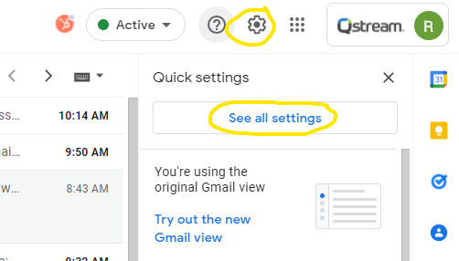
- Under the “General” tab, scroll down to “Signature” and paste the image/text you copied from above in the field:
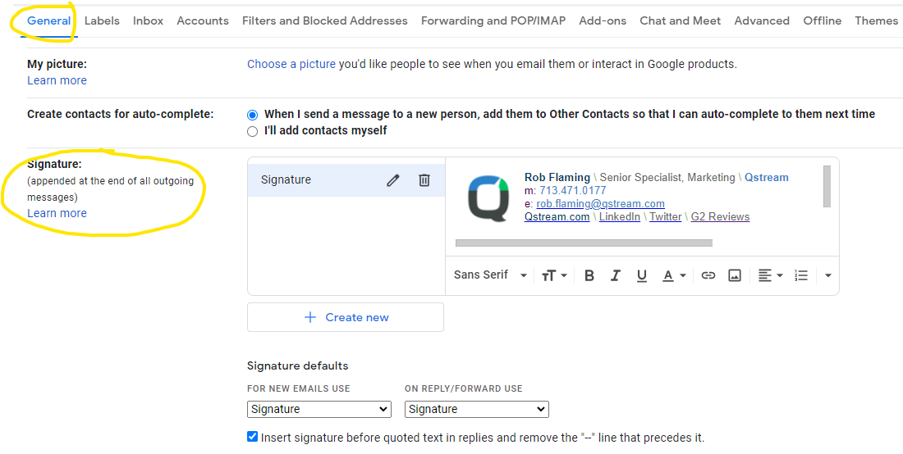
- Edit your Name, Title, Phone number and Email address in the signature box
- Scroll to the bottom and hit “Save Changes”
- Your email signature is now updated

Apple Mail signature instructions:

- Copy the HTML snippet in #marketing-matters slack channel
- Follow the instructions here to add the signature
- Edit the signature in Apple Mail with your information
- Drag your new email signature from “All signatures” into “Google”
- Choose your new signature that you created at the bottom

